**Description:** user should not be logged in to amazon with in correct email and correct password while login.

Launch amazon application in chrome with url <https://www.amazon.in/>

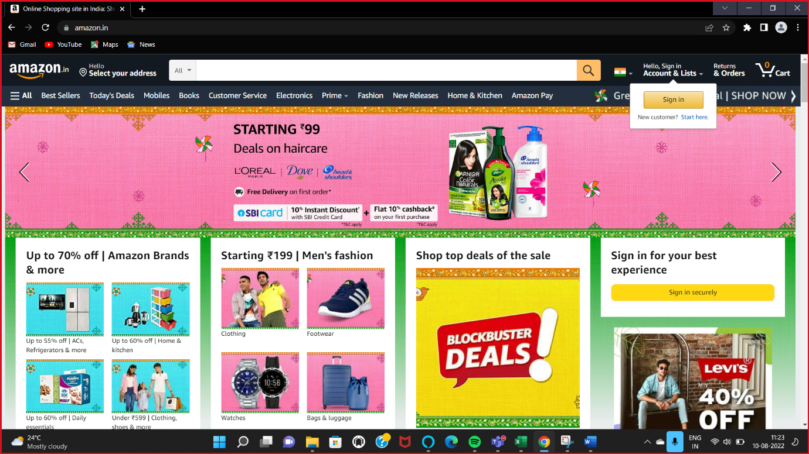

User clicks on Sign in button

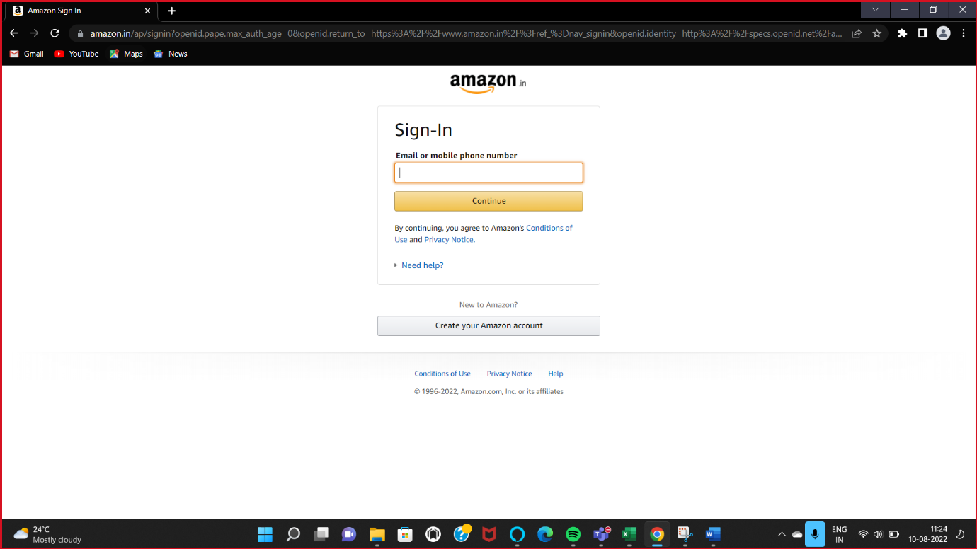

User enters incorrect email id-"**abczgmail.com**" in username field and clicks continue

